**Report on Reverse Factor 5DR and 20DR Effectiveness in the Chinese Stock Market**

In this report, we examine the effectiveness of the reverse factors 5DR (5-Day Reversal) and 20DR (20-Day Reversal) on the Chinese stock market. We assess their performance in terms of:

* Profit and Loss (PnL)
* Turnover Ratio (TVR)
* Annualized return over time
* Overall and recent cumulative excess return
* Sharpe Ratio
* Maximum Drawdown (MDD)
* Industry Exposure
* Size exposure
* Factor monotonicity
* Factor group average size
* Factor distribution
* Effect of delay on factor information ratio(IC)

The results will be displayed and analyzed to provide insights and thoughts on the dynamics and behavior of the Chinese stock market.

**Introduction to Key Financial Performance Metrics**

**1. Profit and Loss (PnL)**

Profit and Loss (PnL) is a key financial metric used to evaluate the performance of a trading strategy or investment portfolio. It represents the total gains or losses generated by the portfolio over a specified period. PnL is crucial for assessing the effectiveness of trading decisions and understanding the overall profitability of an investment strategy. It can be broken down into components such as cumulative PnL, cumulative long PnL, and cumulative short PnL, each providing insights into different aspects of the trading strategy's performance.

**2. Turnover Ratio (TVR)**

Turnover Ratio (TVR) is a measure of the trading activity within a portfolio. It is calculated as the total value of trades executed over a period divided by the initial capital or portfolio value. TVR indicates how frequently assets are being bought and sold within the portfolio. A higher TVR suggests more active trading, while a lower TVR indicates a more passive investment approach. Analyzing TVR helps in understanding the liquidity and transaction costs associated with the trading strategy.

**3. Annualized Return Over Time**

Annualized return is the geometric average return earned by an investment each year over a specified time period. It provides a standardized measure of performance, allowing for comparison across different time frames and investment strategies. Annualized return accounts for the effects of compounding, making it a reliable indicator of long-term growth. Monitoring the annualized return over time helps investors assess the consistency and sustainability of a trading strategy's performance.

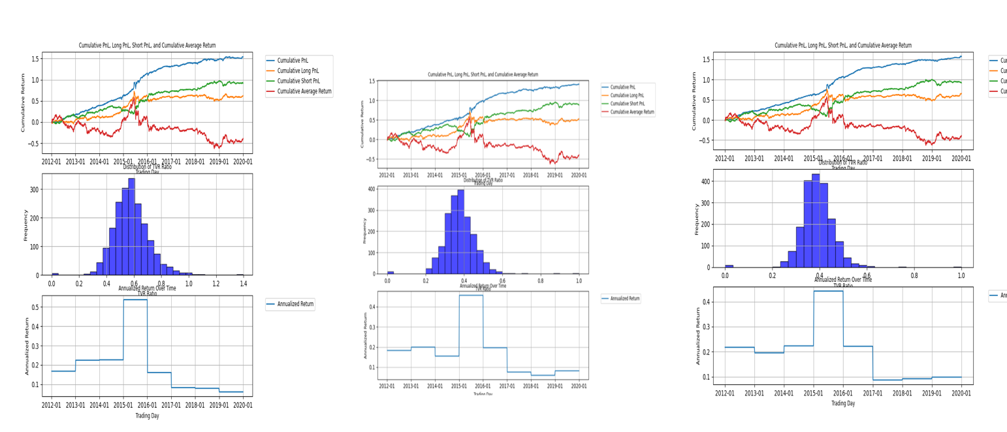

Pnl, tvrratio, and annualized return of 5dr normalized factor, decayed alpha, and industry neutral alpha

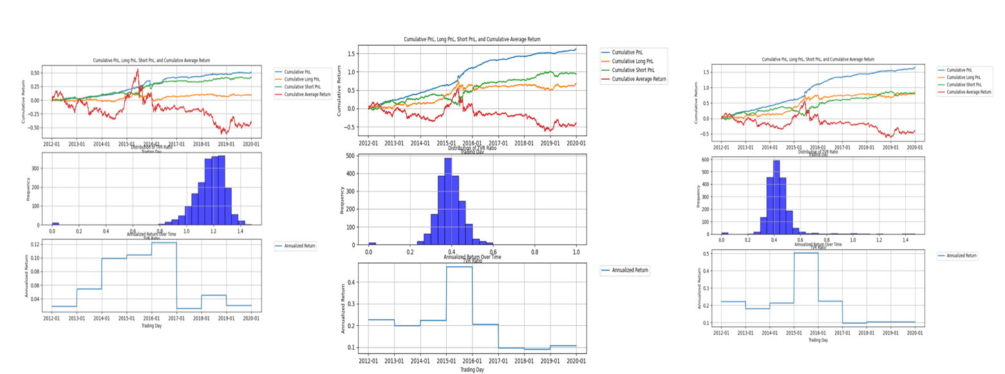

Pnl, tvrratio, and annualized return of 5dr uniform alpha, industry size neutral alpha and winsorized alpha

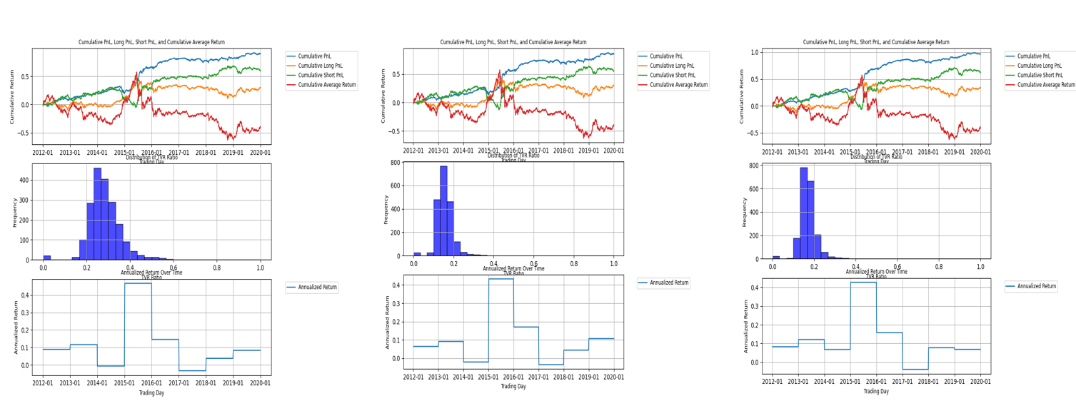

Pnl, tvrratio, and annualized return of 20dr normalized factor, decayed alpha, and industry neutral alpha

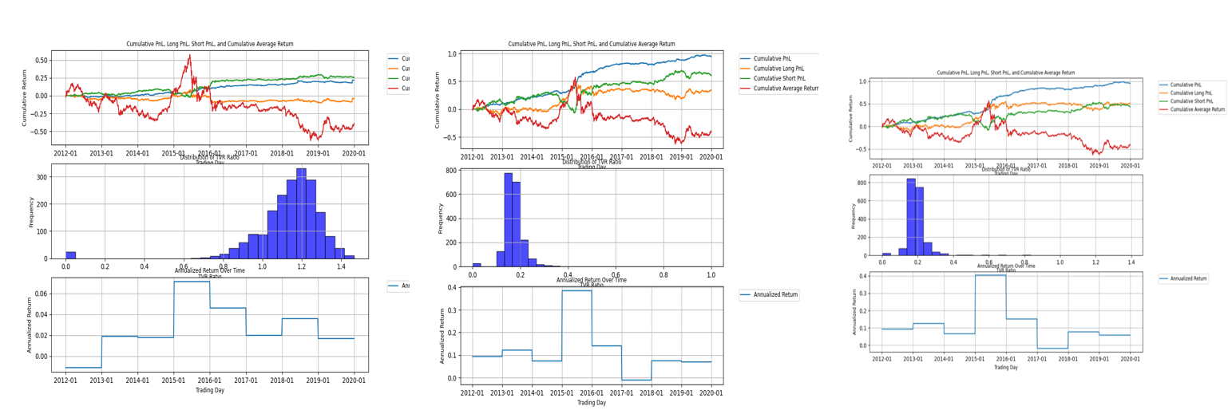

Pnl, tvrratio, and annualized return of 20dr uniform alpha, industry size neutral alpha and winsorized alpha

PNL Analysis:

Based on the performance of the 5DR and 20DR strategies, along with their variants, 5DR Winsorized Industry Size Neutral Alpha offers the best Profit and Loss (PnL) over time.

In addition to the insights already provided, it is also worth noting that the 5DR strategy often exhibits higher Profit and Loss (PnL) compared to the 20DR strategy, which is likely due to its shorter investment horizon. This shorter span allows the 5DR strategy to react more quickly to market changes, which could potentially lead to more profitable trades.

**TVRRATIO Analysis:**

The turnover ratio, often abbreviated as TVR, is a critical metric in portfolio management.that reflects the frequency of trading activities. It has been observed that the decay of alpha, can substantially decrease the TVR. This reduction in TVR can be advantageous in mitigating trading costs in practical scenarios. Furthermore, a 20-day revision (20DR) strategy typically results in a lower TVR compared to a 5-day revision (5DR) strategy. This is because the 20DR approach adapts more gradually to market fluctuations, leading to fewer alterations in portfolio positions. Consequently, this slower reaction to market dynamics contributes to a more cost-effective trading approach.

**Annualized Return Analysis:**

The annualized return graph provides a clear illustration of the temporal dynamics of the non-daily revision (NDR) factor's efficacy. It reveals that the alpha associated with the NDR factor was notably effective between 2012 and reached its zenith in 2014, achieving an average annualized return of 0.50. This period marked a high point in the factor's profitability. Nevertheless, subsequent to 2014, the factor's effectiveness and profitability experienced a marked decline. This downturn coincided with an increase in the factor's size, which appears to have negatively impacted its performance. By the latter part of the observed period, the average annualized return had diminished to 0.05, indicating a substantial reduction in the factor's contribution to portfolio returns.

**4.overall and recent excess cumulative return**

Excess cumulative return represents the additional return generated by a trading strategy or investment portfolio compared to a benchmark or expected return. It helps in understanding how much extra profit or loss the strategy has produced over a certain period. The excess return can be broken down into different components such as overall excess PnL, excess long PnL, and excess short PnL. These components provide insights into the performance of different segments of the trading strategy.

Comparing overall performance with recent performance is crucial for several reasons. First, it allows for a comprehensive trend analysis. Overall performance provides a long-term view of the strategy's effectiveness, highlighting its sustainability and robustness over different market cycles. In contrast, recent performance offers a short-term perspective, showing how the strategy has been performing in the current market environment. This short-term perspective is particularly important to identify if the strategy is adapting well to recent market conditions or if there are any signs of decline.

Second, this comparison is essential for evaluating factor effectiveness. Consistency in performance both overall and recently indicates a reliable strategy. A strategy that shows consistent excess returns in both perspectives is likely more dependable. Additionally, market conditions and dynamics change over time. A strategy effective in the long term but underperforming recently may indicate a need for adjustment. Conversely, a strategy that performs well recently but not over the long term might be exploiting current market anomalies, suggesting a potential risk if those anomalies dissipate.

Third, this approach aids in risk management. Discrepancies between overall and recent performance can signal potential risks. For example, if recent excess returns are significantly lower, it might indicate increased market volatility or inefficacy of the current trading signals. Understanding both perspectives allows for better decision-making regarding portfolio adjustments, hedging strategies, and risk mitigation techniques.

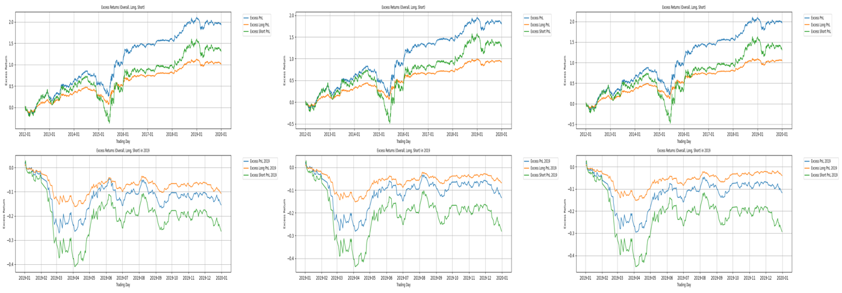

Overall and recent cumulative excess return of 5dr normalized factor, decayed alpha, and industry neutral alpha

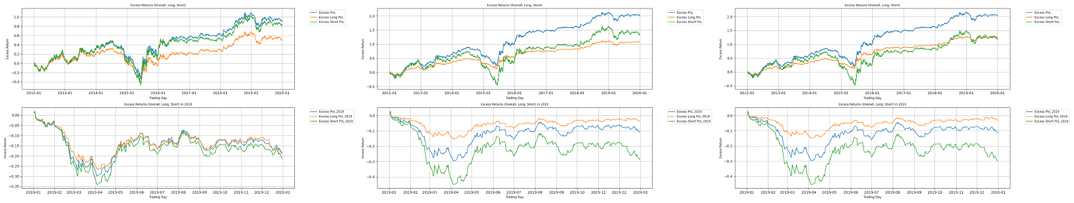

Overall and recent cumulative excess return of 5dr uniform alpha, industry size neutral alpha and winsorized alpha

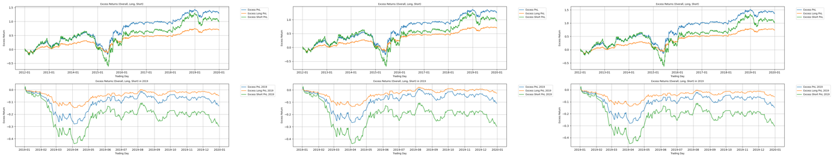

Overall and recent cumulative excess return of 20dr normalized factor, decayed alpha, and industry neutral alpha

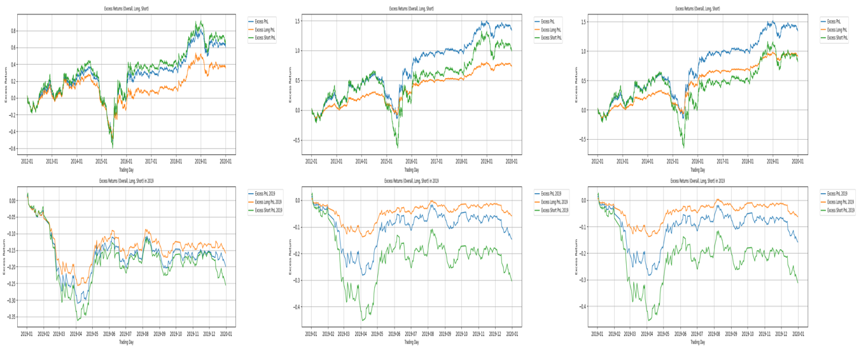

Overall and recent cumulative excess return of 20dr uniform alpha, industry size neutral alpha and winsorized alpha

The provided graphs illustrate the overall and recent excess cumulative returns. The overall excess cumulative returns track the additional profit or loss generated by the strategy, with separate lines for the overall excess PnL, excess long PnL, and excess short PnL. The recent excess cumulative returns focus on the additional returns generated in the year 2019, providing a more immediate view of the strategy's performance with similar breakdowns for long and short positions.

The graph indicates that both raw and processed alpha exhibit a negative or significantly diminished cumulative excess return in recent periods compared to the 2012 to 2019 timeframe. This trend underscores a notable decline in the factor's effectiveness in recent years, suggesting potential challenges in sustaining its predictive power and robustness in the current market environment. Such a shift may necessitate a reevaluation of the factor's utility and the exploration of alternative or supplementary indicators to maintain investment performance.

**Sharpe Ratio and Maximum Drawdown Analysis:**

**5.sharpe ratio**

The Sharpe Ratio is a measure used to evaluate the risk-adjusted return of an investment. It is calculated by taking the difference between the return of the investment and the risk-free rate, and then dividing this by the standard deviation of the investment's excess return

**6. maximum drawdown(mdd)**

Maximum Drawdown (MDD) measures the largest single drop from peak to trough in the value of a portfolio or investment before a new peak is achieved. It is expressed as a percentage of the peak value.

|  |  |  |  |  |
| --- | --- | --- | --- | --- |
| **Alpha Type** | **5DR Sharpe** | **5DR MDD** | **20DR Sharpe** | **20DR MDD** |
| **Normalized** | **2.3894** | **0.378** | **1.39** | **0.028** |
| **Decayed** | **2.19** | **0.335** | **1.34** | **0.026** |
| **Neutral** | **3.204** | **0.0359** | **2.06** | **0.023** |
| **Industry Uniform** | **0.8827** | **0.0611** | **0.99** | **0.014** |
| **Industry Size**  **Uniform** | **3.30** | **0.0324** | **2.32** | **0.018** |
| **Winsorized industry size uniform** | **3.45** | **0.0295** | **2.30** | **0.020** |

Among the various alpha strategies, the 5-day revision (5DR) winsorized industry size-neutral alpha exhibits the highest Sharpe ratio, indicating superior risk-adjusted returns. Conversely, the 20-day revision (20DR) variant of the same alpha strategy demonstrates the lowest maximum drawdown (MDD), signifying a more resilient performance during market downturns. The graphical representation of these metrics suggests that the 20DR strategy provides a more conservative investment approach, characterized by a lower MDD. However, this conservatism comes at the expense of a reduced Sharpe ratio, reflecting a trade-off between risk mitigation and return potential.

**Industry and Size Exposure**

**7. industry exposure:**

Industry exposure refers to the proportion of a portfolio's investments allocated to specific industries or sectors. This metric is crucial for understanding the concentration of risk within a portfolio. When a significant portion of a portfolio is invested in a particular industry, it is more vulnerable to sector-specific risks and events. For instance, economic downturns, regulatory changes, technological advancements, or shifts in consumer preferences within that industry can significantly impact the returns of the securities involved.

**8.size exposure**

Size exposure refers to the allocation of a portfolio's investments based on the market capitalization of the securities it holds. Market capitalization, or market cap, is the total market value of a company's outstanding shares and is used to categorize companies as large-cap, mid-cap, or small-cap. Each category carries different risk and return characteristics. Large-cap stocks, generally more stable and less volatile, represent well-established companies with substantial market presence. Conversely, small-cap stocks, while potentially offering higher growth opportunities, tend to be more volatile and sensitive to market fluctuations.

Understanding and managing size exposure is crucial as it influences the risk-return profile of a portfolio. Overexposure to small-cap stocks, for instance, can increase the portfolio's volatility and susceptibility to market downturns. On the other hand, a heavy tilt towards large-cap stocks might limit growth potential but provide stability.

**Industry Neutralization:**

Industry neutralization involves adjusting a portfolio to minimize the impact of industry-specific risks by equalizing exposure across industries. This strategy can enhance the effectiveness of factor-based investing by isolating the performance of the factors from industry influences.

**Improved Factor Signal:** By neutralizing industry effects, the true predictive power of factors such as value, momentum, or quality can be better assessed. This ensures that the factor's performance is not unduly influenced by industry-specific trends or shocks.

**Enhanced Diversification:** Industry neutralization can lead to a more balanced portfolio, reducing the risk associated with over-concentration in any single industry. This helps in achieving more stable and consistent returns over time.

**Risk Reduction:** By mitigating industry-specific risks, neutralized portfolios are less likely to suffer significant drawdowns due to adverse events affecting particular sectors. This can improve the overall risk profile of the portfolio and enhance its Sharpe ratio and maximum drawdown metrics.

**Size Neutralization:**

Size neutralization aims to minimize the impact of market capitalization on the portfolio's performance by equalizing exposure across different size categories. This process helps isolate the true impact of investment factors, such as value or momentum, by removing the size bias. It ensures that the factor's effectiveness is not skewed by the inherent characteristics of large or small-cap stocks. Size-neutral portfolios are balanced and can achieve more consistent returns by diversifying risks associated with different market cap categories. This approach enhances the Sharpe ratio by improving the portfolio's risk-adjusted returns and reduces maximum drawdown by limiting exposure to the volatility of small-cap stocks.

The research analyzed the most recent 20 trading days to track the cumulative return contribution of different industries and sizes. This investigation aimed to provide insights into the exposure within various alpha subgroups, focusing on both industry and size factors. By examining the performance and allocation across different sectors, the research sought to understand how industry-specific factors influenced overall returns and identify potential areas of risk concentration. Simultaneously, the analysis of size exposure and return provided insights into how market capitalization affected portfolio performance. The findings from this dual analysis of industry and size exposures offered a comprehensive view of the factors driving returns and the associated risks, enabling a more nuanced approach to optimizing portfolio management.

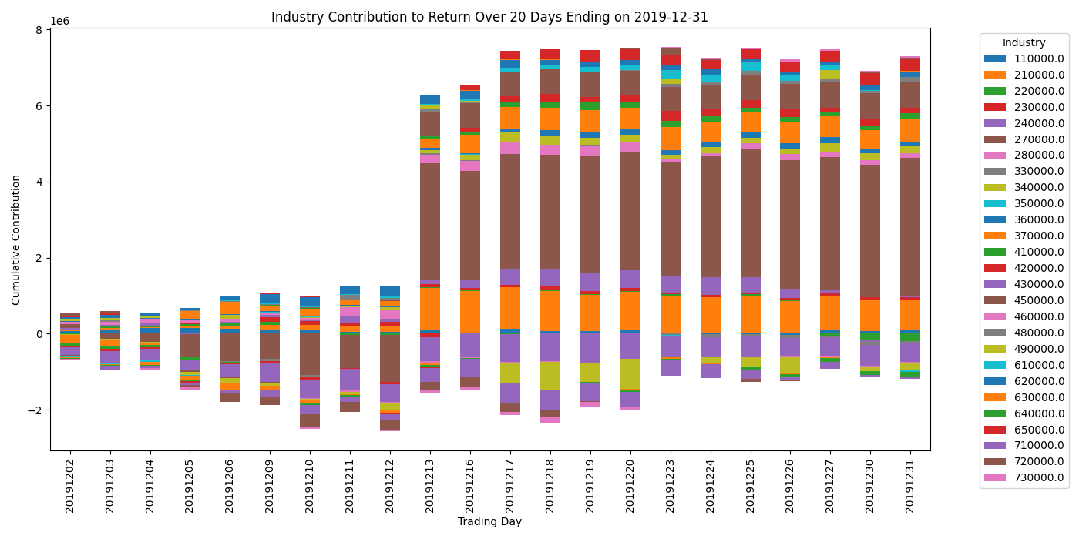

Industry contribution to return over recent 20 days

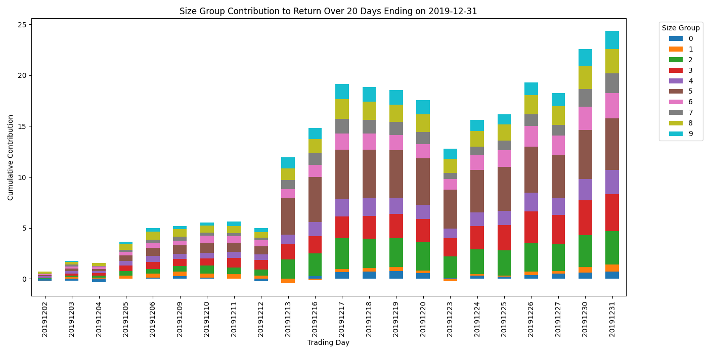

Size contribution to return over recent 20 days

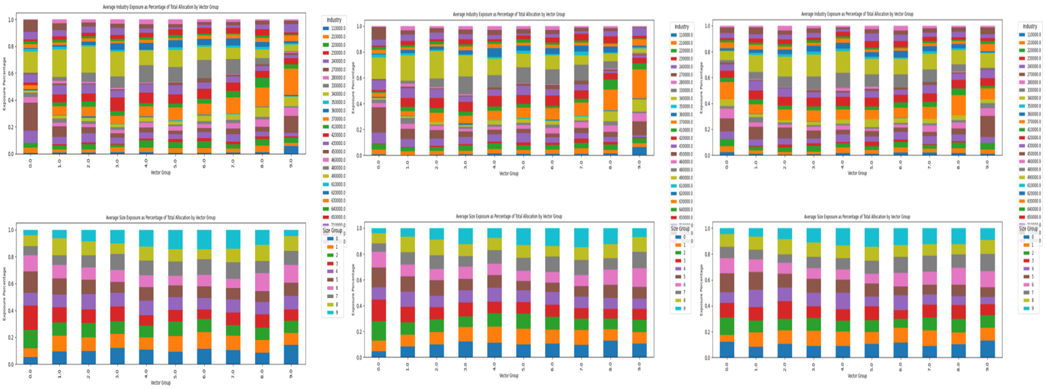

Industry and size exposure of 5dr normalized factor, decayed alpha, and industry neutral alpha as percentage of total allocation by vector group

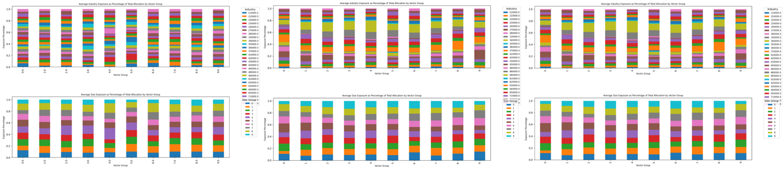

Industry and size exposure of 5dr uniform alpha, industry size neutral alpha, and winsorized alpha as percentage of total allocation by vector group

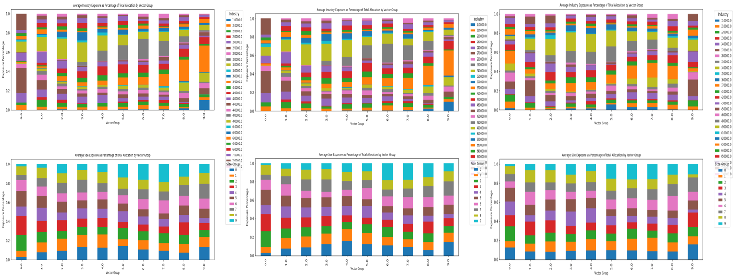

Industry and size exposure of 20dr normalized factor, decayed alpha, and industry neutral alpha as percentage of total allocation by vector group

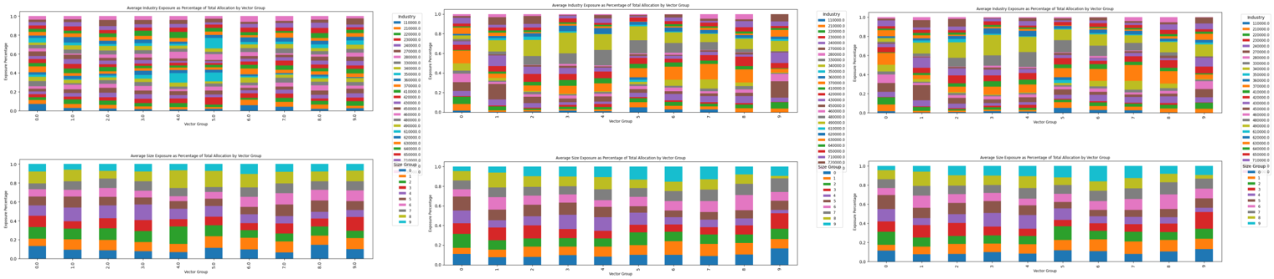

Industry and size exposure of 20dr uniform alpha, industry size neutral alpha, and winsorized alpha as percentage of total allocation by vector group

The industry cumulative contribution to return, along with the grouping analysis of industry exposure across different alpha value groups, provides valuable insights into the risk and return characteristics of various industries within a portfolio. The analysis indicates that industries 270000 and 340000 exhibit a higher exposure to extreme alpha value groups. This heightened exposure to the extremities of alpha values suggests that these industries are more susceptible to significant swings in performance, which in turn implies higher volatility. As a result of this increased volatility, it is likely that a larger portion of the capital is allocated to these industries on days when their alpha values are extreme.

Industry neutralization helps reduce the impact of industry preference in the factor, making the industry exposure of industry-neutral alpha significantly different from pre-neutralized values. This process enhances accuracy and diversification, accounting for the improved Information Coefficient (IC) and Sharpe ratio. The benefits of industry neutralization are evident in the more balanced risk-return profile and greater consistency in performance metrics, highlighting its importance in sophisticated portfolio management.

Similarly, the analysis of size contribution to return involves categorizing stocks into 10 distinct groups based on their market capitalization, or size. For each of these size groups, the cumulative return is calculated and plotted over time. Concurrently, the size exposure of each alpha value group is assessed and mapped. The findings reveal that size groups with higher cumulative returns tend to have a greater exposure to extreme alpha value groups. This correlation suggests that stocks with larger market capitalizations that are performing well are also more likely to be associated with extreme alpha values.

The increased exposure to extreme alpha groups within the high-performing size categories can be indicative of higher risk. This is because extreme alpha values may signal a higher degree of uncertainty or volatility in the stock's performance. Consequently, a portfolio with a significant allocation to these stocks may experience greater fluctuations in returns, which can be undesirable, especially in risk-averse investment strategies. To mitigate this risk, size neutralization is employed. This process involves adjusting the alpha signals to account for the size factor, thereby reducing the impact of market capitalization on the portfolio's performance. By neutralizing the size effect, the portfolio can achieve a more balanced exposure across different size groups, which helps to diversify the risk associated with extreme alpha values. As a result, size neutralization can lead to a more stable and potentially less risky investment outcome, as it minimizes the uneven exposure to high-performing, large-cap stocks that are associated with extreme alpha groups.

**Factor Grouping Analysis:**

**9. factor monotonicity**

factor monotonicity refers to the consistent and orderly relationship between a factor's values and the corresponding performance or returns of a set of assets. In financial modeling and portfolio management, a factor is typically an attribute or characteristic used to predict future returns, such as momentum, value, size, or volatility. Monotonicity in this context means that as the factor values increase or decrease, the returns of the assets consistently follow a similar pattern, either increasing or decreasing.

Monotonicity is important for evaluating factor effectiveness because it indicates the reliability and predictive power of the factor. If a factor is truly predictive of future returns, one would expect a clear, monotonic relationship between the factor's values and asset performance. For example, if the factor is momentum, higher momentum values should consistently correspond to higher future returns, while lower momentum values correspond to lower future returns.

**10. factor group average size**

The factor group average size metric is an essential tool for understanding the dynamics of factor-based investment strategies. By dividing the factor into ten groups based on its value, and then calculating the average market capitalization within each group, investors can gain insights into the biases and tendencies of the factor exposure. This metric helps identify whether a factor is predominantly selecting large-cap or small-cap stocks, thereby revealing potential size biases. Different size categories typically exhibit distinct risk-return profiles, and understanding these preferences is crucial for managing portfolio risk. Moreover, this metric aids in performance attribution by pinpointing which size categories are driving portfolio returns, allowing for informed adjustments to ensure balanced and diversified exposure across market capitalizations. This comprehensive view helps in creating a more stable and robust investment strategy by addressing any unintended size biases within the factor.

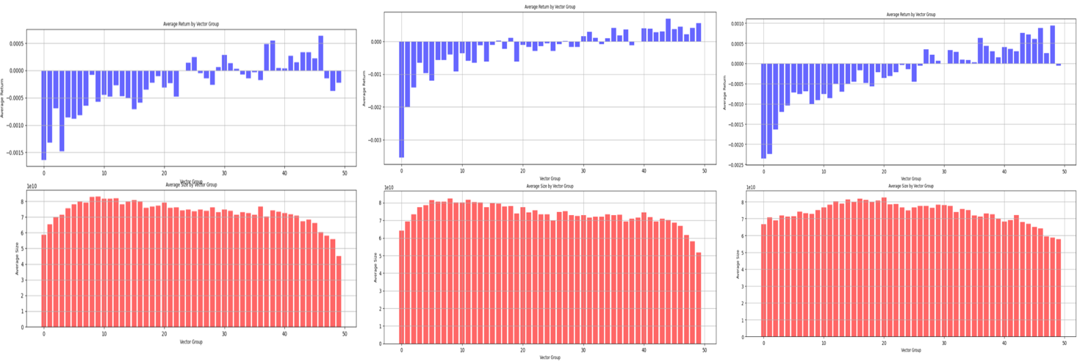

Factor monotonicity and grouping average size of 5dr normalized factor, decayed alpha, and industry neutral alpha as percentage of total allocation by vector group

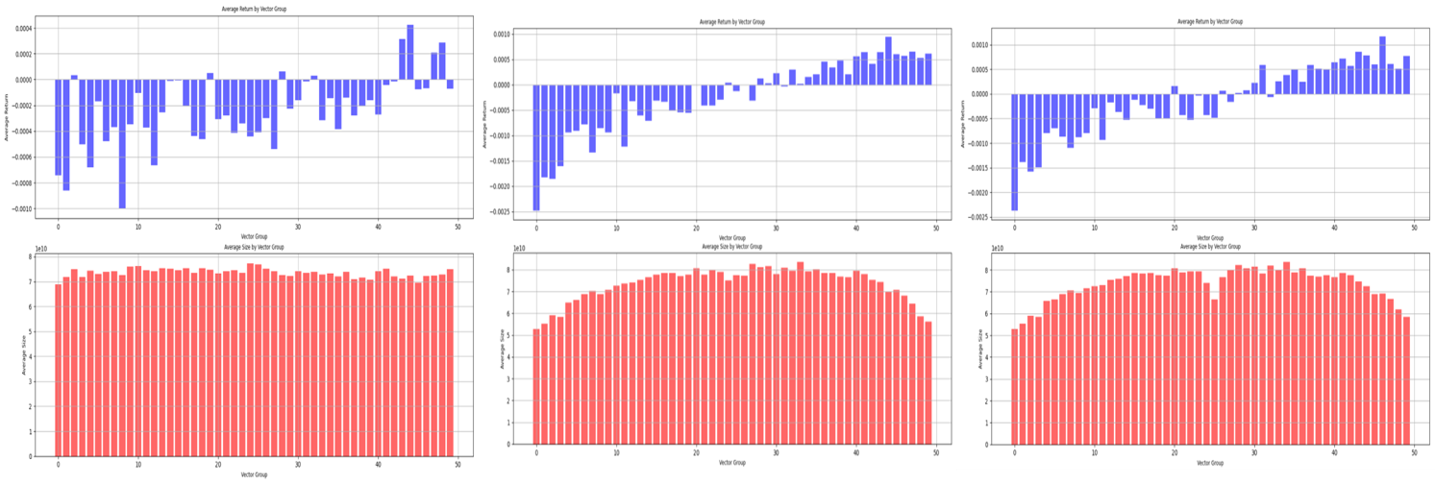

Factor monotonicity and grouping average size of 5dr uniform alpha, industry size neutral alpha, and winsorized alpha as percentage of total allocation by vector group

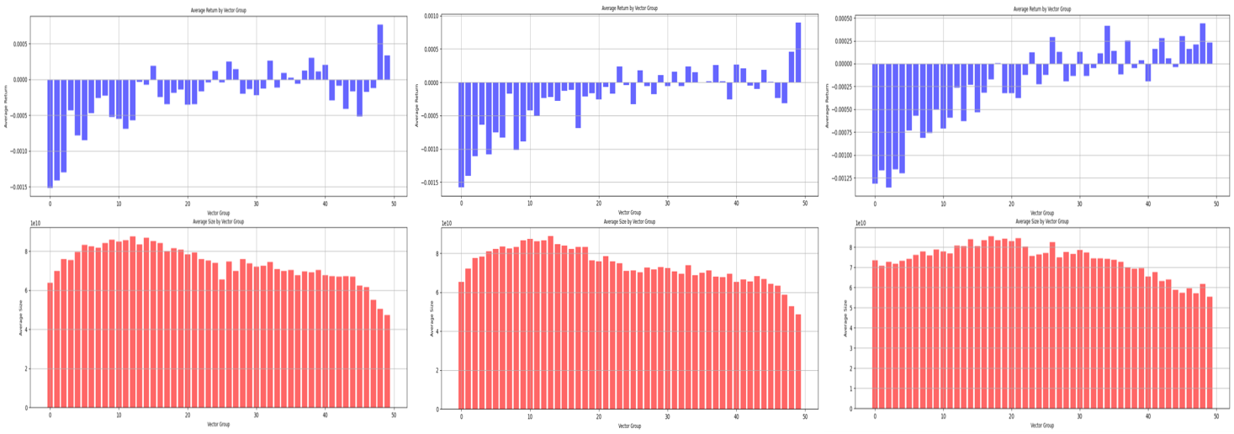

Factor monotonicity and grouping average size of 20dr normalized factor, decayed alpha, and industry neutral alpha as percentage of total allocation by vector group

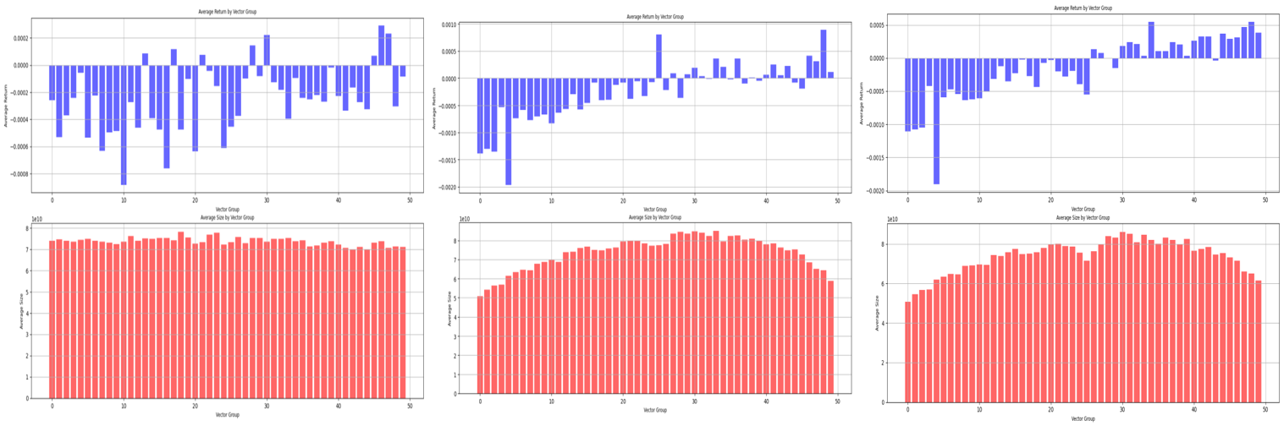

Factor monotonicity and grouping average size of 20dr uniform alpha, industry size neutral alpha, and winsorized alpha as percentage of total allocation by vector group

Monotonicity is a critical metric in quantitative trading for assessing the effectiveness of alpha signals. It evaluates the consistency of the relationship between alpha values and subsequent stock returns, reflecting the reliability of alpha in predicting future returns. The analysis of vector grouping reveals that raw alpha exhibits relatively weak monotonicity. However, the application of decay, enhances the monotonicity of alpha signals. This improvement is essential because increased monotonicity is associated with higher Information Coefficient (IC) values. The IC measures the correlation between predicted and actual returns, with a higher IC indicating superior predictive power of the alpha model. Consequently, the enhanced monotonicity resulting from neutralization processes contributes to a higher Sharpe ratio, reflecting better risk-adjusted returns.

Furthermore, it is observed that the 5-day revision (5DR) of processed alpha data tends to exhibit stronger monotonicity compared to the 20-day revision (20DR). This suggests that the 5DR strategy is more responsive to alpha signals, leading to a more consistent alignment between alpha predictions and actual stock performance.

The analysis of size distribution within alpha groups provides insights into the relationship between stock size and alpha values. The average size of stocks within extreme alpha groups (those close to 1 and -1) is generally smaller. This pattern suggests that smaller-sized stocks, typically characterized by higher volatility due to lower market capitalization and potentially less stable financials, are more likely to exhibit extreme alpha values. Extreme alpha values indicate strong predictive signals, either positive or negative, suggesting that these stocks are expected to significantly outperform or underperform the market. The higher volatility of smaller stocks can lead to larger price swings, which the alpha model may capture as extreme signals.

However, the uniform alpha approach, which mandates equal capital allocation across all industries regardless of alpha values, presents an exception. In this case, the size distribution within alpha groups may not follow the same pattern, as the strategy is designed to ignore alpha signals and maintain balanced exposure across different market capitalizations. The observation that smaller stocks tend to have higher alpha values aligns with the notion that these stocks can offer greater return potential due to their volatility, but also come with increased risk.

The analysis of the most recent 20 trading days tracks the cumulative return contribution of different industries and size groups. This investigation provides insights into industry and size exposure within various alpha subgroups, aiming to understand how specific factors influence overall returns and identify potential areas of risk concentration. The industry cumulative contribution to return, along with the grouping analysis of industry exposure across different alpha value groups, indicates that industries such as 270000 and 340000 exhibit higher exposure to extreme alpha value groups. This heightened exposure implies that these industries are more susceptible to significant swings in performance, indicating higher volatility. Consequently, a larger portion of capital is allocated to these industries on days when their alpha values are extreme.

Overall, industry and size neutralization effectively reduce the impact of industry and size preferences in the factor, leading to a more accurate and diversified portfolio. This improvement is reflected in the enhanced IC and Sharpe ratio. Additionally, the analysis of size contribution to return shows that size groups with higher cumulative returns tend to have greater exposure to extreme alpha value groups. This correlation suggests that high-performing, large-cap stocks are more likely to be associated with extreme alpha values, which can indicate higher risk due to increased volatility. Size neutralization helps achieve a more balanced exposure across different size groups, minimizing the uneven exposure to high-performing stocks associated with extreme alpha groups and leading to a more stable investment outcome.

**11. factor distribution**

The factor distribution, as depicted in the provided graphs, illustrates the spread of alpha values within the range of -1 to 1 for both raw and neutralized factors. This distribution is crucial in evaluating the effectiveness and reliability of the alpha signals generated by the quantitative model.

The shape and spread of these distributions provide insights into the behavior and characteristics of the alpha signals. A well-distributed alpha within this range indicates that the model is generating a diverse set of signals, capturing various aspects of market movements. If the distribution is overly concentrated around zero, it may suggest that the model's signals lack strength or are too conservative, potentially missing out on profitable opportunities. Conversely, a distribution with extreme values might indicate higher volatility and risk associated with the alpha signals.

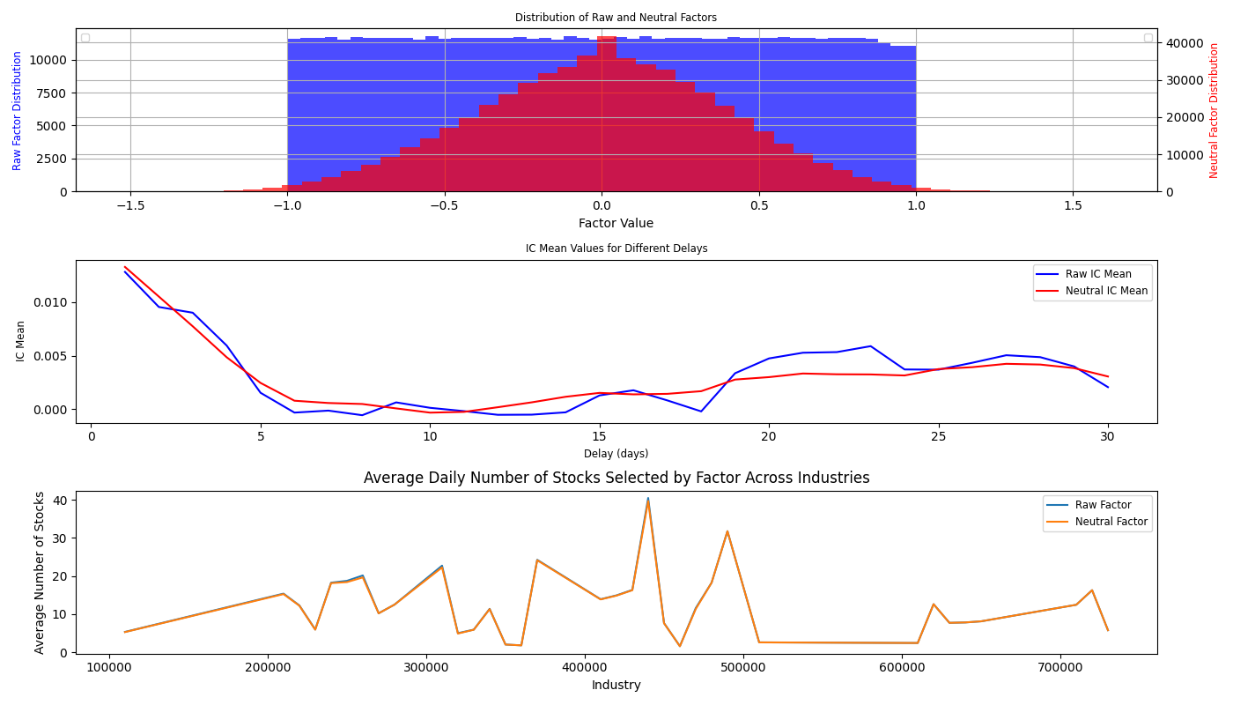

From the factor distribution analysis, it is evident that the raw alpha (normalized factor) displays a more uniform distribution, whereas the industry size-neutral alpha exhibits a normal distribution. This distinction is significant in evaluating the effectiveness and risk profile of the alpha signals.

A uniform distribution in raw alpha indicates a relatively even spread of alpha values across the entire range. This characteristic can be advantageous for capturing a diverse array of market signals, potentially leading to higher returns by exploiting various market inefficiencies. However, this approach also introduces greater volatility and risk, as the uniform distribution suggests a higher incidence of extreme values, which may not always correlate with actual market movements.

Conversely, the normal distribution observed in the industry size-neutral alpha suggests that most alpha values are clustered around the mean, with fewer occurrences of extreme values. This distribution reflects the smoothing effect of neutralization techniques, such as adjusting for industry and size factors, which reduce the impact of outliers and noise. This approach can be advantageous in minimizing risk and ensuring more consistent returns, as it mitigates the influence of extreme values and industry-specific shocks.

In terms of return potential, the uniform distribution of raw alpha may provide more opportunities to capture significant market movements, potentially resulting in higher returns. However, this comes with increased risk and the potential for substantial drawdowns. On the other hand, the normal distribution of neutralized alpha is better suited for minimizing risk and achieving stable returns. By creating a more balanced and diversified portfolio, the normal distribution helps manage the effects of extreme values and industry-specific volatility.

**12. effect of delay on information ratio**

The effect of delay on the Information Ratio (IR) is an essential consideration in evaluating the effectiveness and robustness of a trading strategy. The Information Ratio measures the performance of an investment strategy relative to a benchmark, adjusted for the risk taken. Specifically, it is the ratio of the expected active return of the strategy to the tracking error, providing a standardized measure of risk-adjusted return.

In the context of factor-based investing, the delay effect examines how the predictive power of the factor changes over different time horizons. Initially, factors are often evaluated with a delay of one day (delay1), meaning the factor values are used to predict the next day's returns. However, to understand the stability and persistence of the factor's predictive ability, it is insightful to calculate the mean Information Coefficient (IC) over longer delays.



The analysis of the delay versus Information Coefficient (IC) plot reveals important insights into the performance and stability of alpha signals over different timeframes. The neutralized alpha, after decay, demonstrates a smoother IC curve compared to the raw alpha. This smoother behavior indicates that the neutralization process helps to stabilize the predictive power of the alpha signals, making them less susceptible to short-term market noise and more consistent over time.

Both the raw and neutralized IC values exhibit a decreasing trend as the delay increases. This trend suggests that the predictive power of the alpha signals diminishes over longer timeframes. The primary reason for this decrease is that market behavior tends to be more closely aligned with recent data, as opposed to data from further in the past. In other words, the alpha signals are more effective at predicting near-term market movements than those that are more distant in time. This aligns with the understanding that financial markets are dynamic and constantly evolving, with recent information being more relevant for making predictions.

The smoother IC curve of the neutralized alpha indicates that it provides more stable and reliable predictions across different delays. This stability can be attributed to the adjustments made for industry and size factors, which help to reduce the impact of outliers and market anomalies. By incorporating these adjustments, the neutralized alpha becomes less volatile and more consistent, enhancing its utility for longer-term predictions.

**12． Average Stocks per Alpha Group**



The analysis shows that both the raw (normalized factor) and the industry size neutral alpha do not exhibit an observable difference in the number of stocks picked within each industry. This is likely because both strategies include all the stocks in the portfolio. The key difference lies in the position or weight assigned to each stock, rather than the selection of stocks themselves. This distinction in weighting is crucial as it influences the overall portfolio risk and return characteristics.